**Brigham Young University - Maida Withers presentation, Nov 1, 2023**

*LECTURE: “Preserving and Transforming Culture.”*

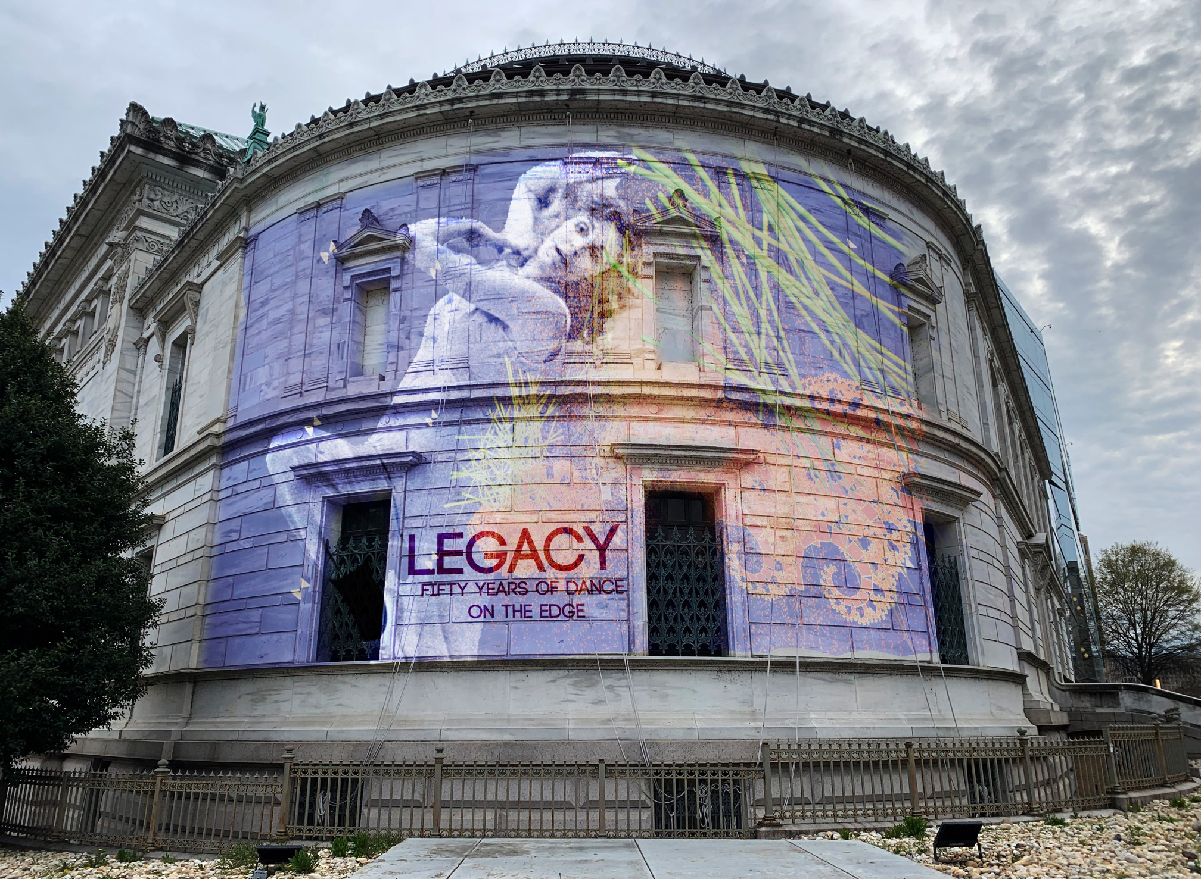

Photo: LEGACY: 50 Years Dance on the Edge

Good afternoon. I am honored to be here with you, today, to share my thoughts and personal reflections on the meaning, influence and power of the arts and culture. I deeply appreciate the opportunity to return as a guest artist to BYU. Thank you Marin Roper and Quinn Mecham.

As the youngest of 8 children in the Woodruff and Isabelle Rust Family, born in Kanab, and raised in Salem, Utah, I lived a spirited life, without wealth or power - a life of freedom that stimulated an abundance of independence, freedom of thought, and daring. (00:21 Total Seconds)

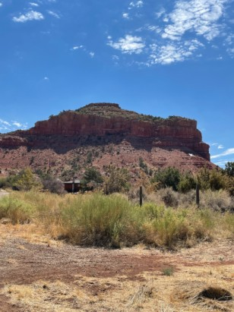Photo: “Indian Dance Hall,” Kanab, Utah

As a very young child in Kanab, I ran fast in the hot red earth in my bare feet; attempted to climb the spectacular “Indian Dance Hall Butte” at age 5 following my brothers Val and Billy; watched in awe the Great American Bald and Golden Eagles that often circled overhead, not knowing at a young age what I would come to know later thru the Utah Project - the great myths and power of these astonishing creatures – “if you know the Eagle you can send and receive messages to/from the Gods;” -- sitting on the wooden fence

above the pasture that also served as the “community” approved sledding hill, I pondered, waiting and imagining “the sun turning to darkness, and the moon into blood!” Such information for a child! There was no access to academies of dance, but what I treasure, then and now, is my life as a laboratory of freedom of thought, risk taking, experimentation, and questioning. I never recovered from this innocent sense of wonder. Instead, I sustained it through my art works, my university teaching, and my family life. (01:00) Total Time)

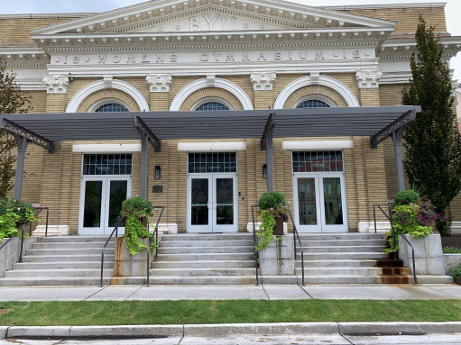 Photo: BYU Women’s Gymnasium

My four years of study at BYU, 1954 to 58, were very important. My class of 7 dancers was the first to receive a bachelor’s degree in Dance at BYU. It was a challenge because dance was trying to find its place and influence in already established programs. We were accustomed to 6 am rehearsals. The Women’s Gymnasium was dedicated to other purposes after 8 am. However, dance is powerful and convincing AND as young dancers we were passionate and driven.   
Very significant at BYU was the opportunity to study with guest artists, Erick Hawkins and Anna Halprin, distinguished thinkers and practitioners - important figures and friends in the emerging world of post-modern dance. While my generation stands in awe of the early pioneers, ultimately, I, along with others, pushed further into a redefinition of dance, liberating performing, creating, while searching for freedom and change. DANCING and MAKING DANCES for my lifetime began here. Thank you, BYU. (01:00)

And today, a new generation is speaking and dance is being redefined for today’s life and values.

*I appreciate the opportunity to address BYU’s engaging topic:*

## “Preserving and Transforming Culture.”

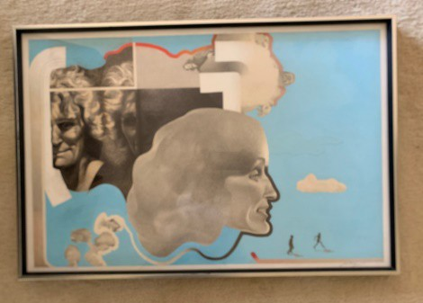 To set the stage, I would like to introduce you to Maida Withers and the Dance Construction Company, a not-for-profit cultural organization established in 1974 in Washington, DC with five dancers, two, who were also practicing visual artists, along with a sound sculptor who was part of the movement of a new genre called electronic music. From the beginning, there was significant influence of a multidisciplinary approach that embraced the inclusion of diverse artists, scientists, and others, in the process of research while creating and performing.

The goal of this artist-driven organization was to establish “an aesthetic for change!” (00:40)

*Regarding the topic of Transformation:*

Starting out as artists in the radical 60s and 70s, we opened the door wide and joined with others intentionally seeking and aspiring to break new ground...to push boundaries for what is art...obeying the commandment “to continually search to find something new, innovative, and, perhaps, unthinkable before not just new content, but a search for

change a new existence as artists, a new expression for being human.” (00:30)

NOW & NEW We felt we were part of something happening. We were ambitious and

pushing ourselves and our audiences, through failures and success. We asked hard questions as we worked to establish a loose manifesto template, of sorts, rejoicing in a period of CHANGE. We were innocent but determined taking ourselves as serious

as possible in a somewhat, giddy relationship with all the possibilities being stirred up!

I am grateful that my life-time and the time for pioneering were on the same trajectory. The times were a perfect fit for my inquisitive, somewhat unorthodox nature, and my unending ideas for projects. (00:41)

Although we began simply with ourselves, we felt we were part of something larger, a time of cultural power, celebration, distinction and, specifically, in my case, more global opportunity. (01:23)  
**(Total 01:14)**

Regarding Preservation:

With the advent of personal computers, I began assembling and digitizing information about my choreography, collaborations, and performances. The collection is one of the earliest archives and timeline created by an individual dancer.. Dance Construction Company’s online archive (maidadance.com) provides access to a large body of projects, more than fifty years of dance works, works that break boundaries between audience and performers, works that explore social, political, and cultural issues while deconstructing our role as artists in an invigorating and dramatically changing world from 1950 to early 2000. (00:41)

The TIMELINE and ARCHIVES present a comprehensive history that highlights descriptions and text, videos and photographs of stage works, improvisation performances, site projects, along with media platform / events that reveal the Company’s extended reach and interests. National

and internationally recognized collaborators – dancers, composers/musicians, poets/writers, 3-D computer animators, visual artists, filmmakers, scientists, and technologists – are featured on the individual web pages for each work **(Total: 00:58)**

**In reflection – when ideas are being formed:**

What is the question we ask?

What is relevant that could be valued by others?

What process will help investigate the question?

What role could others play in this creative process?

What is the result, or outcome, of the art created.

How will the work and the process have value and how will others be involved? (20:20)

An extensive body of diverse work has been created for stage, film, and site locations including work created for extreme environments and special relationship to museums. Improvisation, collaboration and research are important processes. Technology and media provide interactive tools as we work to “break new ground” through the arts.

I am honored to share with you a few select works drawing on data from the Dance Construction Company archive, 1970 to 2022: (00:31)

# SITE WORK

I support the notion that “the world is a stage!” SITE work is an ongoing interest. Washington, DC is noted for the many extraordinary monuments to MEN of GREATNESS, MEMORIALS to accomplishments and events of history. DC has been a fertile ground for SITE WORKS that celebrate life and bring an audience out of the theatre into new arenas flush with memories, passion, and meaning. (00:24)

**VIDEO _ FIFTY YEARS_1072 TO 2022 – use for all projects up to finale https://vimeo.com/763973869**

**02:03 to 02:18**

# ( WPA REHEARSAL)

**(00.15 seconds)**

**continue 02:19 to 02:29 Holy Rood Cemetery (25 Total Seconds)**

In the early days, we rehearsed and performed in an abandoned dental office, home of Washington Project for the Arts, the first interdisciplinary arts organization funded by the newly formed National Endowment for the Arts. This early work became *White Mansions*, a performance in Holy Rood Cemetery, at dusk, that tells a story of life and continuity in death. A piece of white silk served as a connector as it became a wedding veil, a table cloth for celebration, a wrap for death. Several young dancers were in the cemetery carrying flowers and playing in white clothes engaged as if they lived there.

The cast departed the cemetery in a gold Roll’s Royce leaving the audience in the dark among the tombstones. (00:42)

**05:00 to 05:13**

# IWO JIMA MONUMENT

We recognized the sacredness of the national Iwo Jima Marine Corps War Memorial as we joined in humble support of the dedication, optimism, and bravery of Marines who have given their lives in defense of the United States since 1775.

(00:17)  
**continue 05:13 to 05:48   
SUNDAY MANEUVERS**

**(35 Seconds)**

Sunday Maneuvers – an environmental/political site event at Theodore Roosevelt Island National Park. Aspects of President Roosevelt’s life and government policies became subjects for the performance: outdoorsman and soldier; speak softly and carry a big stick; love of nature vs war; national parks and forests. The detailed script for the one- hour event featured a community of 32 dancers and musicians. Dancer’s movements were often cued by the sound of airplanes overhead, departing and arriving from National Airport. (00:35)

**10:28 to 11:00**

**(32 Seconds Total Time)**

# WET AND WONDERFUL IN WASHINGTON, DC (FAST)

Wet and Wonderful in Washington, DC was an urban dance and water sculpture site event at Western Plaza on Pennsylvania Ave between the White House and the US Capitol. Nearby National Theatre was under construction, covered with sheets of plastic. For 15 days from 9 to noon, eleven dancers rehearsed on site. Each day was a public performance for tourists and office workers. The wind changed direction daily so choreography changed direction too. Cars on the street provided the sound score along with cellist Rogelio Maxwell. Penn Avenue is the route the soon to be President takes to the Capitol on Inauguration Day!

(39:00 Seconds Total Time)

**19:47 to 20:13**

(22:00 Seconds Total Time)

# SANDS CYCLES

*SANDS CYLES* is a poetic dance and environment video, a landsite process of creating art for the Earth and ecology shot at Coral Dunes, Utah and White Sands, New Mexico. Verabel Call Cluff on camera and myself improvising each day for over a month.

Improvised images were edited based on Joseph Campbell’s *Hero with a Thousand Faces: the Innocent, the Orphan, the Martyr, Caretaker, Warrior, Destroyer, Magician, and Ruler*.

(00:27 Seconds Total Time)

**46:59 to 47:19**

**1:00:49 to 1:01:37**

# KYIV, UKRAINE – 60 MOVES WITH FUTURE GAZE.

(01:25 Total Time)

2018 **KYIV, UKRAINE – 60 MOVES WITH FUTURE GAZE**...concluding section of an evening-length site performance for the 60th Gala Anniversary of the National Exhibition Center of Ukraine. Maida, US, and Anton Ovchinnikov, Ukraine, co-choreographers with 18 Ukraine dancers explores the relationship between architecture (dominance of RUSSIAN architecture in Kyiv) and the human body in order to better understand how architecture aﬀects our identity and patterns of behavior. What do we feel today, being surrounded by the ideology of the past – a past deeply embodied in Stalinist architecture? And who are WE – the people who have lived in times of dramatic change, who are still in the process of self-identification – the passionate and innovative spirit of youth. Live music by Steve Hilmy, USA.

(00:52 Total Time)

**ALL SITE WORK Total time:**

**ENVIRONMENT -** STAGE PERFORMANCES and FILMS:

My grandparents, William and Sarah Rust, and my father Woodruff Rust, built and operated the V.T. Lodge, 1926 to 1936, that is located just 18 miles from the North Rim of the Grand Canyon. 93 years ago, electricity, running water were such complicated issues. The beautiful lodge continues today under the fifth owner.

Environmental tourism would best describe their motives today. I am grateful for the

love of the earth instilled in me from their example. (00:34)

Research on environment issues and natural phenomena has resulted in elaborate and diverse dances referencing nature and the environment. (00:08)

**18:52 to 19:11**

# DANCE FOR THE EARTH

*Rolling Thunder* and Messenger Eagle18:52 to 19:11

In 1992, Maida and the Company participated in the first global United Nations Earth Summit (Eco ’92) in Rio de Janeiro with 100 International Artists for Ecology for six weeks. *Rolling Thunder* and Messenger Eagle and Dance for the Earth were created for the Summit. Brazilian dancers joined in my choreography to perform on the beach stage and performances on Sugar Loaf Mountain and a commission to create a new site work in the Rock Garden of the famous Museu de Arte Moderna. Brazil and Brazilian artists continue to be collaborators, especially in the area of dance and technology. (00:37 Total Time)

**21:29 to 21:52**

**ANCIENT LANDS – ANCIENT PEOPLES,** Red Earth Stage, Korea

*Ancient Lands – Ancient Peoples* was important to the development of initiatives. Several solos, expressions of “the female” and the earth, were created from the Utah Project. On tours in China, Korea, and Malaysia, these solos were associated with shamanism. (00:15 Total Time) **continue 21:53 to 25:453**

**UTAH PROJECT & UTAH * SPIRIT PLACE “* SPIRIT PLANET * TUKUHNIKIVATZ**

(3:38 Total Time)

*The Utah Project*, involved a period of six years with two or three annual trips for research with my colleague and video artist, Verabel Cluff.

An entry from my journal:

“In 1988, I returned to the land of my birth in Utah with a group of five artists for a five- week experiment of living and dancing on selected land sites to create a dance

video. The lands in Utah were sacred to me and to my family history relating to that region since the late 1800’s. I was drawn to the strong presence and spirit of the ancient and present indigenous peoples as well. As dancers, we rehearsed in the recreation hall of the Mormon Church, but generally spent most of our time at four specific land-site locations selected for our ambitious project. Each day we understood better how to join with the forces of nature as we danced and filmed on the red rocks and cliffs. We experienced the extraordinary physical and spiritual powers of this place and its inhabitants, and we glimpsed our most inward selves. Slowly I began to make linkages between my concern with new art, my own culture, and these ancient sites and people. The connections involve the relationship of nature and culture and, more importantly,

raise questions relating to the very meaning and function of art.” (journal entry) (1:20 Time)

Utah * Spirit Place * Spirit Planet * Tukuhnikivatz, a major multimedia project resulting from this research, was commissioned by Lincoln Center for Lincoln Center Out of Doors, GREAT DANCE in the Bandshell Series, NYC. National collaborators including Brent Michael Davids, Mohican, composer, and Will Goins Moreau, Cherokee singer, Bruce Hucko, photographer, Joe Pachak, guide, and so so many others. Sunny and Hardy Red, Blanding, Utah, made the annual residencies in Utah possible donating the use of their home and van for use for six weeks. 2500 people attended the amazing performance at Lincoln Center. (00:40 paragraph) (02:00 Total Time).

**Continue 37:27 to 38:35**

# FARE WELL: PARCHED EARTH..REMEMBRANCES FOR TOMORROW (2008)

Kenya, Africa (01:08 Total Time)

In 2008 I began the FareWell Project, a series of six dances addressing my sense of despair related to the environment and human choices.

FARE WELL: PARCHED EARTH...REMEMBRANCES FOR TOMORROW was a

project in Kenya, Africa created with 6 male and 3 female Kenyan Dancers (Masai) in a 3-week residency at the GoDown Center for the Arts. Maida, Wendell Cooper, Assistant, and Steve Hilmy, composer/musician, were in Nairobi as Cultural Envoys for the U.S. Department of State and the US Embassy – just 3 weeks following the brutal civil uprising in Kenya that had caused intense personal trauma for our Kenyan dancers. In Parched Earth we collaborated to reveal the deep understanding of the Earth and nature by the African people and to further understand violence through the current human disruption of cherished values. (00:50)

FareWell dances created included:

FareWell: The Others – Uncertain World FareWell – Tipping Point (ICE) (2008)

FareWell and Hell-O (with poet Alex Caldiero for the Utah Arts Festival in 2008) FareWell to the End of the World as We Know It or Dancing Your Way to Paradise FareWell – Rising Tide (2009)

(00:36

**INTERACTIVE TECHNOLOGY**

**11:01 to 11:54 LASER DANCE**

**(53 Seconds Total)**

LASER DANCE a four-part evening-length space odyssey (Part I: Departure; Part II: Quest; Part III, Domain; Part IV, Rites/Skylight/and Departure) Laser Dance takes place inside a large-scale installation of argon laser beams created by Rockne Krebs, one of the earliest visual artists to

develop laser art (1968). We had our first collaboration in 1971. Laser Dance is about leaving and finding a new home in the universe.

For Laser Dance, Laser beams originating from upstage center project toward 50 mirrors placed in Lisner Auditorium on walls and on stage. When the beams are interrupted (human body or stilts) the visual grid of beams would be altered on stage and above the audience in the house. Sound installation by Bob Boilen with Synclavier II electronic instrument is a riveting score, generously enhancing the choreography. Dancers wore protective goggles and clothing. *Laser Dance*, was recorded on 16mm film due to the need for darkness to conduct the laser light. EPA spent 8 hours before the performance to approve the safety of the event for the audience. Laser Dance is one of several works that reveal my curiosity about man/woman on planet earth and ideas related to the universe and “other worlds.” Laser Dance, “A bold, imaginative space-age enterprise.” Alan Mike Kriegsman, Washington Post (1985)

(01:29 Total Time)

**27:45 to 29:42**

## DANCE OF THE AURORAS – FIRE IN THE SKY

(03:27 Total Time)

*DANCE OF THE AURORAS – FIRE IN THE SKY* resulted in two projects: A stage work and a documentary film on Auroras and research with scientists in Russia, Norway, Alaska, and with NASA in DC.

The Performance in four parts included The Sun/Virtual Sun; Solar Wind Towards Magnetosphere; Magnetic Storm Seen from Above; and View from the Earth. An evening-length work of dance, music, and visual presentation. A groundbreaking poetic voyage in space from the Sun through Earth’s auroras, the mystic luminaries of the arctic and Antarctic skies also known as the northern and southern lights. In its vision, Dance of the Auroras reclaims the connections between science and art, between technology and the natural world. This eloquent and innovative performance draws its audience into a ritual both ancient and new.

In two sections dancers used an early version of the wireless mouse to alter and manipulate in real time large-scale projected cyber worlds, 3-D animations by Tania Fraga, computer artist, Sao Paulo, Brazil. NASA provided movies and images of the Sun from satellites and images of Earth’s auroras from orbiting spacecraft and special ground-based cameras before such data was posted online. Music was created and performed live by the Global House Band, Oslo, Norway. Dance of the Auroras premiered at The Northern Lights Festival in Tromsö, Norway and in Washington, DC at Lisner Auditorium, a 1500 seat theater. Dance of the Auroras was also performed in St. Petersburg, Russia. A public presentation was given at the Smithsonian National Air and Space Museum – Albert Einstein Planetarium, Washington, DC the week prior to the premiere in Lisner Auditorium. (01:39 Total Time)

**55:00 to 55:42; Maida and Anthony Solos (42 seconds total)**

***MindFluctuations***

**(00:42 Total Time)**

MindFluctuations: A 90-minute interactive collaboration between dance, neuroscience, 3D projected computer art and live electronic music, that continues my fascination with the connection of the human body and mind to interactive and innovative technology - art that creates a multi-sensory world.

A neural headset (**Emotiv**), worn by the dancer, is used to digitize their emotional states that interface with the processes within virtual 3D environments created by an artist in the computer. These interactions exist by visually transmitting the impact of the brainwaves captured by the BCI helmet into the performance arena in real time and/or through the projection of stored nine-part stimuli to create a moving and immersive environment for the participating performers and audience. (00:49)

**(no video)**

**Speech / Time (00:25 / No video!)**

My work is not necessarily compatible with a recurring “season” of dances presented in a theatre. Investment in time and creativity evolves into several works for stage, site, and film. It has been my great pleasure to perform and create work in more than a dozen countries. I prefer residencies that engage collaboration not simply presentation. I am interested in questions related to cultural envoys. When the US Government funds the international project, are artists assumed to represent the American people? (00:32)

**POLITICS – RUSSIA & America   
32:09 to 32:47 (37 seconds total)**

**MAIDA & ANTHONY In FORMER RUSSIAN (GULAG) DUNGEON**

It has been my great honor to engage in more than a dozen projects in Russia and with Russian dancers since 1996, often with support of the Department of State and the US Embassy in Russia.

In 2004 I, and dancer Anthony Gongora, participated as guest artists in an extraordinary 5 week residency in Russia on Solovky Island in the White Sea near the Arctic, the location of one of the first Soviet Era GULAGs, deadly forced labor camps that imprisoned millions of political figures, ordinary people, and criminals. We danced and filmed improvisations, daily, in various locations on various islands, trying, often to be invisible and even pretending to be tourists. This first clip is in one of the dungeons of the historic 14th Century Monestary turned GULAG where we danced without permission. When priests or tourists came near the video artist cried “Red Light” or “Green Light” – the signal to stop or continue. These experiences became PART I of our large scale American/Russian collaboration, Thresholds Crossed. (01:00 Total Seconds)

continue – 32:48 to 33:26 (38 seconds total)

GULAG / ART ANGAR (FILM)

(38 seconds total)

GULAG / ART ANGAR is a political, documentary dance film shot in a unique Soviet Era architectural structure on Solovky Island, Russia. The building was originally the hangar for the dirigible (airship) that delivered supplies to the prisoners and workers in the GULAG. The choreography is based on photographs of 9-11 prisoners at Abu Ghraib, Guantanamo Bay, Cuba. Prisoners related to 9-11 World Trade Center tragedy in NYC. The video has been selected for film showings in Burgundy, France, Istanbul, Embassy of Finland in Washington, DC, New Delhi, India, and others. This choreography for the duet is Part II of the stage work, *Thresholds Crossed.* (00:42 Total Seconds)

**THRESHOLDS CROSSED STAGE PART 1 33:59 to 35:32**

**(01:32 Total Time)**

# THRESHOLDS CROSSED STAGE PART 2, 3, 4

**Continue not break 35:32 – 37:27**

**(02:06) Total Time part 2, 3, 4)**

**(03:29) Thresholds Crossed Stage total**

**(05:39)combined dungeon & Thresholds Crossed, stage work) continue Thresholds Crossed Part I: 34:00 to 35:32;**

**continue 35:33 to END: 37:27 (Part II. (03:38 minutes**).

Thresholds Crossed (2006) is a 4-part evening-length multimedia work, a kinetic fusion of East and West, that fearlessly explores the events, ideology and humanistic issues that link the US with the former Soviet Union and contemporary Russia. The work is about our shared experiences with love of country, violence of war, sorrow for loss, and passion for life. It is a highly charged interactive performance by 4 Russian, 1 Ukrainian, and 6 American dancers. The work was created during a one-month residency in Russia and a one-month residency in the USA with all dancers present. The work was performed in DC and also toured to 3 cities in Russia. Part I of the work is about Russia and the Gulag; Part II is about USA and Guantenamo Bay Prison. Part III is about the violence of war; Part IV ended on a positive note because the relationship of Russia and USA at that period of time. (01:00 Total time)

**MUSEUMS**

Dance in the museum setting has long been an interest of mine. I have asked the question for years. What are the possible relationships of performing arts to the concepts of museums? What are the possibilities?

In 1974 the Company and composer, John Driscoll created our first evening-length performance in the Columbus Museum of Art for the Gala Opening of the new

contemporary wing. (00:25)

**58:58 to 59:55 (00:57)**

(00:57 Seconds Total Time)

# ICE BERGS - GLACIAL DRIFT

National Building Museum presents Dance, Music, and Poetry in the Surreal Underwater-World of ICEBERGS, a multi-sensory experience, designed by James Corner Field Operations, NYC. GLACIAL DRIFT, a site-responsive performance of dance, music, and text, offers a delightful, yet introspective time in a spectacular constructed environment of nature away from the real world. Glacial Drift explores the boundaries between the magnificent beauty and wonder of icebergs and the impact of humans on the environment. A sonic architecture fills the immense space enveloping the ICEBERGS installation with live electronic music by John Driscoll and Steve Hilmy. Poems by Alex Caldiero and David McAleavey, spoken by Maida Withers, re-ignite our memory and perception of time and place.

(00:51 Total Time)

[**http://vimeo.com/871301256**](http://vimeo.com/871301256) **00:01 – 06:30**

**(LEGACY: Exhibition, Immersive Installation and Performance) (06:30 Total Time)**

**LEGACY: Fifty Years DANCE ON THE EDGE**

In 2022, Corcoran Galleries in Washington, DC, presented LEGACY: Fifty Years Dance on the Edge an engaging exhibition of the history and substance of the voice of Maida Withers and the Dance Construction Company. There is a distinctive voice in the works, consistency coupled with a broad range of ideas and daring – freedom to approach the controversial and unknown. Robin Bell’s immersive installation is a stunning mix and collision of dance – an experience on/off the walls and ceiling. There is beauty, humor, and power in Robin Bells delightful mix of images that highlights Maida Withers and the Dance Construction Company’s extensive fifty-year archive that explores the intersection of dance, visual art, and social action. Robin Bell’s installation brings new life to dance from the past through technology. (00:56)

SUMMATION

We are 20 years into a new century. In these deeply confusing times, what is or will be the contribution of culture? Will culture be remembered and honored? Jason Farago, New York Times critic, argues in a recent story, *Out of Time*, October 15, “that ours is the least innovative century for culture in 500 years.”

There is conjecture that the social media and more explicitly, perhaps, technology and the information revolution are radically changing our values. How much digital knowledge must I have to participate as an artist ?

We have praised the arts for insight and ingenuity. WHAT QUESTIONS WILL BE ASKED TODAY?

How will innovation continue within the context of the major influence of technology including AI.

Will the arts and culture continue to play the necessary role in our human experience and be a positive power of influence in each life.

Perhaps the arts will have even more influence and remain a balance to information density, repetition, and reframing?

I deeply appreciate the opportunity to be here today. Thank you so much for sharing this time with me. I look forward to our upcoming discussion.

(Total Time 01:17)

Maida Withers